**Data Management and Database Design – 09/28/2022**

**Class Notes: Assignment 2**

* Assignment 2 is about “Modelling One – Ten English questions for your database”.
* Basically, these ten questions will be what you want your database to answer.
* The due date for this assignment is on the 8th of October 2022.
* If in a team, each team member will have to come up with 10 questions each. For example: if Team A has 4 members, then team A will have to produce 40 questions in total.
* If in case, a team member falls short of a question, he/she will have to make sure the rest of their questions are meaningful and have quality to them. i.e., no 2*2=4 type questions.
* If a team/team member had already framed their questions and had already submitted them along with their first assignment, they will have to upload the same questions again on canvas and on GitHub.
* Students are requested to talk to the TAs if there are any questions.

**Class Notes: YouTube video on “UML use case diagram tutorial”**

* We can use UML tool to design use case diagrams as one of many ways to do so.
* Any other tool is welcome to design use case diagrams.
* This video was not adequate enough to make sense to learn about Use Case Diagram design. Optional to watch.

**Class Notes: YouTube video on “All about use case diagrams, what is a use case diagram, use case diagram tutorial and more”**

* Watch the video on YouTube as per the title above for another perspective about use case diagrams.

**Class Notes: YouTube video on “UML class diagram tutorial”**

* Watch the video on YouTube as per the title above.
* The concept explained on this video is tied to Object Oriented Programming and Entity-Relationship Modeling.
* Important classes for **jobs database** are like Users, Jobs, Company etc.

**Class Notes: ERM Diagrams – YouTube video on “Entity Relationship diagram”**

* Entities of **jobs database** include: companies, jobs, users, skills etc.
* Relationship table can include an EmployeeID and any other ID that can be thought of.
* Figure out what are the things in your **jobs database** and how do they serve purpose in terms of ERM.
* Below figure can shed some light on a basic ER model.

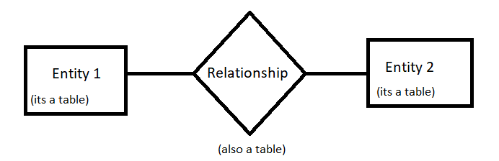

* Two or more entities can make a relationship.
* In other words, a fundamental relationship between two entities is called **Cardinality.**
* There are many types of cardinalities. They are:

1. One to One
2. One to Many
3. Many to One

**Class Notes: Assignment 3**

* Assignment 3 will be based on designing our E-R diagrams.